**SQL Assessment**

**Given below is a Library domain ERD, understand the ER diagram and answer all the questions.**

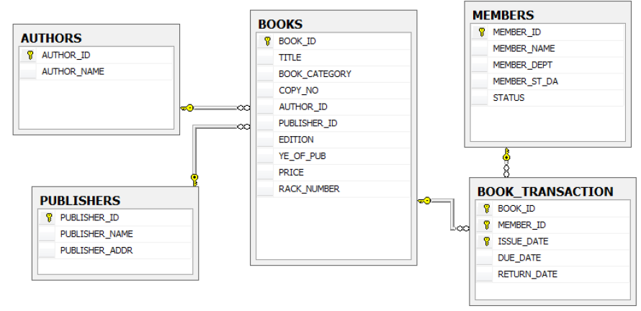

1. How many books are there in each category, in the library?
2. Title wise how may copies of books are available in the ‘rdbms’ category?
3. Which are the categories of books that are least utilized.
4. Which books were not lent during the last quarter of the year(oct-dec 2019)
5. Which author’s book is costliest?
6. Along with member details, list the books that crossed the due date.
7. How many copies of book available in each publication?
8. Which is the costliest book in each publication?
9. How many no. Of books available for “java” in each publication?
10. Prepare a list of books that are due as on date, in delay descending sequence, in the following format:

**Title member name due date delay**